**Data**

Let’s see first if the data is exactly what is shown at our National Television.

library(data.table)  
library(lattice)  
x <- list.files("csse_covid_19_data/csse_covid_19_daily_reports/", pattern = ".csv", full.names = TRUE)  
x <- data.frame(file = x, date = substr(basename(x), 1, 10), stringsAsFactors = FALSE)  
x <- split(x$file, x$date)  
x <- lapply(x, fread)  
x <- rbindlist(x, fill = TRUE, idcol = "date")  
x$date <- as.Date(x$date, format = "%m-%d-%Y")  
x <- setnames(x,   
              old = c("date", "Country/Region", "Province/State", "Confirmed", "Deaths", "Recovered"),  
              new = c("date", "region", "subregion", "confirmed", "death", "recovered"))  
x <- subset(x, subregion %in% "Hubei" |   
 region %in% c("Belgium", "France", "Netherlands", "Spain", "Singapore", "Germany", "Switzerland", "Italy"))  
x$area <- ifelse(x$subregion %in% "Hubei", x$subregion, x$region)  
x <- x[!duplicated(x, by = c("date", "area")), ]  
x <- x[, c("date", "area", "confirmed", "death", "recovered")]  
subset(x, area %in% "Belgium" & confirmed > 1)

Yes, the data is attached in this repository  looks correct indeed. Same numbers as reported on the Belgian Television.

| **date** | **area** | **confirmed** | **death** | **recovered** |
| --- | --- | --- | --- | --- |
| 2020-03-01 | Belgium | 2 | 0 | 1 |
| 2020-03-02 | Belgium | 8 | 0 | 1 |
| 2020-03-03 | Belgium | 13 | 0 | 1 |
| 2020-03-04 | Belgium | 23 | 0 | 1 |
| 2020-03-05 | Belgium | 50 | 0 | 1 |
| 2020-03-06 | Belgium | 109 | 0 | 1 |
| 2020-03-07 | Belgium | 169 | 0 | 1 |
| 2020-03-08 | Belgium | 200 | 0 | 1 |
| 2020-03-09 | Belgium | 239 | 0 | 1 |
| 2020-03-10 | Belgium | 267 | 0 | 1 |
| 2020-03-11 | Belgium | 314 | 3 | 1 |

**Exponential number of cases of Corona**

Now is the outbreak really exponential. Let’s make some graphs.

What is clear when looking at the plots is that indeed infections happen at a exponential scale except in Singapore where the government managed to completely isolate the Corona cases, while in Belgium and other European countries the government lacked the opportunity to isolate the Corona cases and we are now in a phase of trying to slow down to reduce the impact.

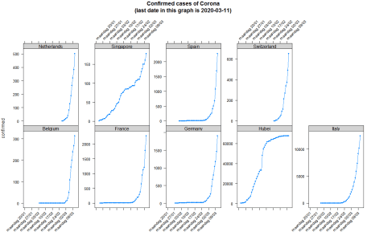

You can reproduce the plot as follows

trellis.par.set(strip.background = list(col = "lightgrey"))  
xyplot(confirmed ~ date | area, data = x, type = "b", pch = 20,   
 scales = list(y = list(relation = "free", rot = 0), x = list(rot = 45, format = "%A %d/%m")),   
 layout = c(5, 2), main = sprintf("Confirmed cases of Corona\n(last date in this graph is %s)", max(x$date)))

**Compare to other countries – onset**

It is clear that the onset of Corona is different in each country. Let’s define the day 0 as the day where 75 persons had Corona in the country. That will allow us to compare different countries. In Belgium we started to have more than 75 patients with Corona on Friday 2020-03-06.  In the Netherlands that was one day earlier.

| **date** | **area** | **confirmed** |
| --- | --- | --- |
| 2020-01-22 | Hubei | 444 |
| 2020-02-17 | Singapore | 77 |
| 2020-02-23 | Italy | 155 |
| 2020-02-29 | Germany | 79 |
| 2020-02-29 | France | 100 |
| 2020-03-01 | Spain | 84 |
| 2020-03-04 | Switzerland | 90 |
| 2020-03-05 | Netherlands | 82 |
| 2020-03-06 | Belgium | 109 |

Reproduce as follows:

x <- x[order(x$date, x$area, decreasing = TRUE), ]  
x <- x[, days_since_case_onset := as.integer(date - min(date[confirmed > 75])), by = list(area)]  
x <- x[, newly_confirmed := as.integer(confirmed - shift(confirmed, n = 1, type = "lead")), by = list(area)]  
onset <- subset(x, days_since_case_onset == 0, select = c("date", "area", "confirmed"))  
onset[order(onset$date), ]

**Compare to other countries – what can we expect?**

Now are we doing better than other countries in the EU. Following plot shows the log of the number of people diagnosed as having Corona since the onset date shown above. It looks like Belgium has learned from the issues in Italy but it still hasn’t learned the way to deal with the virus outbreak the same as e.g. Singapore has done.

Based on the blue line, we can expect Belgium to have next week between roughly 1100 confirmed cases (log(1100)=7) or if we follow the trend of France that would be roughly 3000 (log(3000)=8) patients with Corona. We hope that it is only the first.

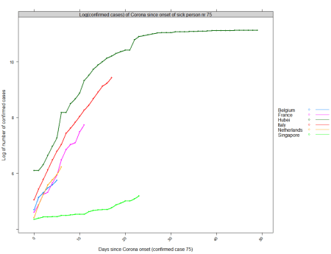

Reproduce as follows:

xyplot(log(confirmed) ~ days_since_case_onset | "Log(confirmed cases) of Corona since onset of sick person nr 75",   
 groups = area,  
 data = subset(x, days_since_case_onset >= 0 &   
 area %in% c("Hubei", "France", "Belgium", "Singapore", "Netherlands", "Italy")),   
 xlab = "Days since Corona onset (confirmed case 75)", ylab = "Log of number of confirmed cases",  
 auto.key = list(space = "right", lines = TRUE),  
 type = "b", pch = 20, lwd = 2)

**Compared to the Netherlands**

Now, are we doing better than The Netherlands? Currently it looks like we are. But time will tell for the future. Give the above trend shown above, I can only hope everyone in Belgium follows the government guidelines as strict as possible.

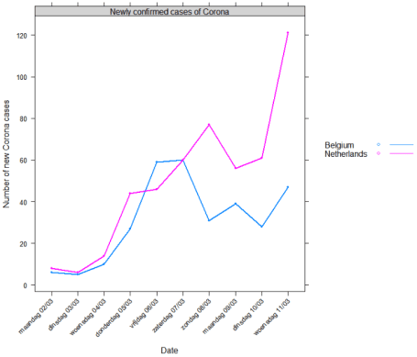

Reproduce as follows:

xyplot(newly_confirmed ~ date | "Newly confirmed cases of Corona", groups = area,  
 data = subset(x, area %in% c("Belgium", "Netherlands") & date > as.Date("2020-03-01")),   
 xlab = "Date", ylab = "Number of new Corona cases",  
 scales = list(x = list(rot = 45, format = "%A %d/%m", at = seq(as.Date("2020-03-01"), Sys.Date(), by = "day"))),   
 auto.key = list(space = "right", lines = TRUE),  
 type = "b", pch = 20, lwd = 2)